**eData & KFS FAQ**

**When does the month close?**eData will have all of the final transactions to complete month-end reports on the 4th working day of the next month. Some eReports will be available on the 5th working day. The time it takes to run and load the eReports is long and variable, which makes it hard to determine when all of the eReports will be loaded into Content Management. Currently it is expected to take 3 or more days to load all of the eReports. Please note that some eReports may not be available until the 8th working day or later.

**Final vs. Processed**The KFS eDoc statuses of Final and Processed are essentially the same. These statuses indicate that the eDoc has fully routed, all approvals required have been obtained, and that the eDoc is finished.

**To find all changes made to an account in KFS:**In KFS, click on “doc search”

Under Document Type enter “ACCT” and click search. This will bring up the screen below where you can then enter your Account Number and Date Created From (entering 7/1/13 should bring back all changes).  After clicking search, the changes to that account made in KFS will be shown at the bottom.

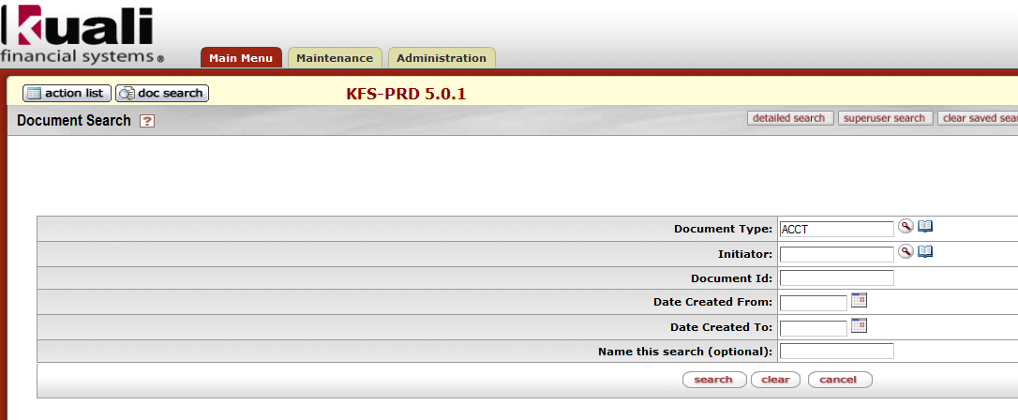

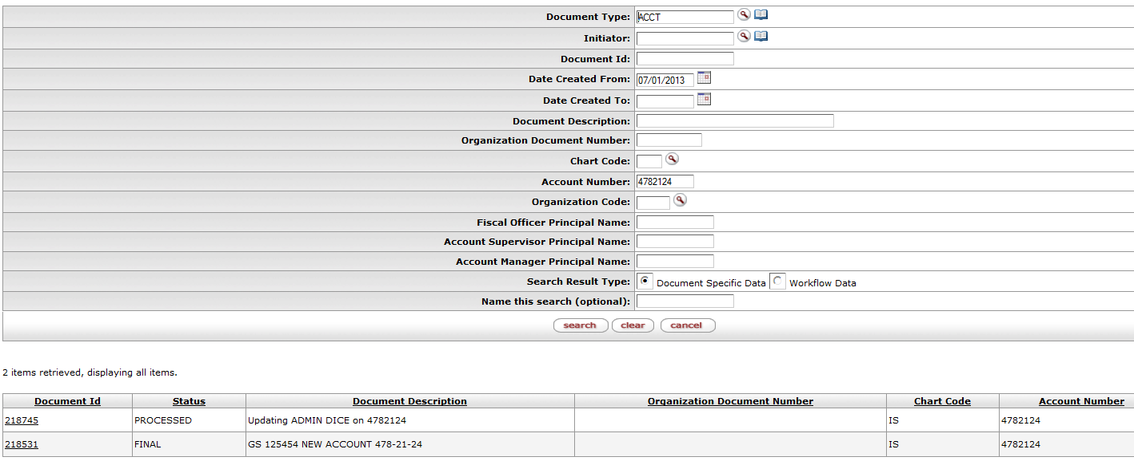

**eReports: SPA Financial Report**eReports are still available in the same place, AccessPlus. To find a SPA Financial report for 6/30/13 or prior, use the set of reports labeled “Prior14” and to find reports after 6/30/13, use “SPA-Financial.”

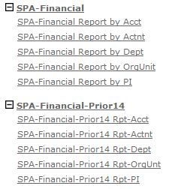

The search criteria will be entered slightly different as well. For example:

Before: in the *Department Abbreviation* field enter “ENT”

Now: In the *Org Dept Code* field, enter “046”, or in the *Org Dept Name* field, enter “ENTOMOLOGY”

Note: In July, the Org Unit Name was not displayed, so if the department was split between Org Units it was uncertain which link to click once the list was rendered. Starting in August, the Org Unit Name is displayed to clarify.

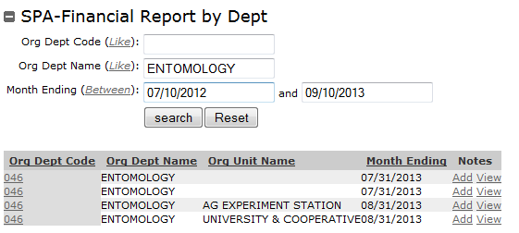

TIP: In eData, the header information for the account is always current. Even if the month is changed to a prior date, the header information stays current. The financial information changes dynamically. To see the prior header information, go to the eReport instead of eData.

TIP: If printing the SPA Financial eReports, note that the reports are no longer the standard one page with the financial report on the front and an encumbrance summary on the back. The financial report may now be on two pages depending upon the number of budget categories. In addition, if there are no encumbrances the summary page is not generated. Please be cognizant of this change so no pages are missed if it is necessary to print an eReport.

**eReport Schedule:**

